# AIR AMBULANCE

### A PROJECT REPORT

#### Submitted by

**ABDUL AZIZ.M**  **(812419106002)**

**AYYANAR.S (812419106010)**

**JEGAN.J (812419106021)**

**KARTHICK PANDIYAN.R (812419106023)**

#### In partial fulfillment for the award of the degree of

## BACHELOR OF ENGINEERING

***In***

**ELECTRONICS AND COMMUNICATION ENGINEERING**

## M.I.E.T ENGINEERING COLLEGE, TRICHY



## ANNA UNIVERSITY::CHENNAI 600 025

## MAY 2023

# AIR AMBULANCE

### A PROJECT REPORT

#### Submitted by

**ABDUL AZIZ.M**  **(812419106002)**

**AYYANAR.S (812419106010)**

**JEGAN.J (812419106021)**

**KARTHICK PANDIYAN.R (812419106023)**

#### In partial fulfillment for the award of the degree

#### of

## BACHELOR OF ENGINEERING

***In***

**ELECTRONICS AND COMMUNICATION ENGINEERING**

## M.I.E.T ENGINEERING COLLEGE, TRICHY



**ANNA UNIVERSITY::CHENNAI 600 025**

##### **MAY 2023**

# ANNA UNIVERSITY - CHENNAI 600 025

## BONAFIDE CERTIFICATE

Certified that this project report **“AIR AMBULANCE”** is the bonafide work of **“ABDUL AZIZ.M (812419106002)”,** **“AYYANAR.S (812419106010)”, “JEGAN.J (812419106021)”, “KARTHICK PANDIYAN.R (812419106023)”** who carried out the project work under my supervision.

###### SIGNATURE SIGNATURE

Dr. M. VIJAY MEYAPPAN M.Tech, Ph.D., Dr. AYSHATHUL FOUZIA ABDUL

GANI M.E., Ph.D.,

###### HEAD OF THE DEPARTMENT SUPERVISOR

Department of Electronics and Department of Electronics and

Communication Engineering Communication Engineering

M.I.E.T Engineering College M.I.E.T Engineering College

Trichy-620007 Trichy-620007

**Submitted for the Project viva-voice held on _________________________**

**INTERNAL EXAMINAR EXTERNAL EXAMINAR**

**ACKNOWLEDGEMENT**

First, we would like to thank the almighty for giving us talents and opportunity to complete our project and then to our family members for their unwavering support.

We would like to express our sincere gratitude to our college chairman and founder **Er.A.MOHAMED YUNUS M.Sc(Engg).,**for providing large facilities in the institution for the completion of the project. We would like to express our thanks and sincere gratitude to our principal **Dr.A.NAVEEN SAIT M.E., Ph.D.,** for encouraging us to do such an innovative project.

Our sincere thanks to the Tamilnadu government scheme, Tamilnadu state council for science and technology ( TNSCST) for sanctioning fund for carrying out the project.

We wish to express our heartfelt thanks and sincere gratitude to our Head of the Department **Dr.M.VIJAY MEYAPPAN M.Tech., Ph.D.,** for his valuable advice to complete this work successfully and also for enthusiastic encouragement to make our effort worthwhile and fruitful.

We are extremely indebted to our project Coordinator **Dr.S.ARCHANA M.E., Ph.D.,** and our project supervisor **Dr. AYSHATHUL FOUZIA ABDULGANI.M.E.,Ph.D.,** who extended her full co-operation and valuable guidance which helped us to take further steps in our project and also supporting us in all times to complete our project successfully. We also thank our all other faculty members and supporting staff members in the Department of Electronics and Communication Engineering for their support and encouragement.

**ABSTRACT**

The aim of this work is to explore the use of air ambulance services as a means of providing rapid medical assistance to critically ill or injured patients in remote or inaccessible areas. An overview of the role and importance of air ambulance services in modern healthcare is examined. Here, we examine the benefits of using air ambulances, such as faster transport times, improved access to medical care, and the ability to transport patients over long distances. The findings of this study will be useful for healthcare providers, policymakers, and emergency services agencies in developing strategies for using air ambulance services effectively and efficiently to improve patient outcomes. The idea proposed in this work makes use of drones and Helium gas balloons facilitating the conveyance on land, water and air. The wheel-mounted drones levitate as they rotate, and float where needed with the help of drones and air bags filled with helium gas. The benefits of this ambulance include reduced transport times, improved patient outcomes, and increased access to healthcare in remote and underserved areas.

**Keywords**— environment friendliness, flying Ambulance Medical system, near-ground space, safety, traffic congestion, urban air mobility.

###### TABLE OF CONTENTS

###### CHAPTER NO. TITLE PAGENO ABSTRACT iv

###### LIST OF FIGURES ix

###### LIST OF ABBREVIATION xi

###### 

**1 INTRODUCTION 1**

|  |  |  |  |
| --- | --- | --- | --- |
| **1.1** | | **INTERNET OF THINGS(IOT)** | **3** |
| **1.2** | | **AIR AMBULANCE** | **3** |
| **2** | **LITERATURE REVIEW** | | **8** |
|  |  | |  |
| **3** | **EXISTING & PROPOSED SYSTEM**  3.1 EXISTING SYSTEM  3.2 EXISTING BLOCK DIAGRAM  3.3 DISADVANTAGES  3.4 PROPOSED SYSTEM  **3.5 PROPOSED BLOCK DIAGRAM**  3.5.1 PROPOSED SYSTEM OF AIR AMBULANCE  3.5.2 BLOCK DIAGRAM OF AIR AMBULANCE  **3.6 PROPOSED BLOCK DESCRIPTIONS**  3.6.1 MOTOR  3.6.2 CONTROLLERS  3.6.3 SENSORS  3.7 ADVANTAGES | | **16**  **16**  **18**  **19**  **19**  **20**  **20**  **21**  **21**  **21**  **22**  **22**  **22** |
| **4**  **5**  **6** | **SYSTEM REQUIREMENTS**  4.1 HAREWARE REQUIREMENTS  4.2 SOFTWARE REQUIREMENTS  **4.3 HAREWARE SPECIFICATION**  4.3.1 BRUSHLESS MOTOR  4.3.2 ELECTRONIC SPEED CONTROLLERS(ESCs)  4.3.3 FLIGHT CONTROLLER  4.3.4 LITHIUM POLY BATTERY  4.3.5 PROPELLER  4.3.6 SERVO MOTOR  4.3.7 GEAR MOTOR  4.3.8 AIR BAG  4.3.9 HELIUM GAS  4.3.10 LCD  4.3.11 TRANSMITTER & RECEIVER  4.3.12 ALUMINIUM CHANNEL  4.3.13 ULTRASONIC SENSOR  4.3.14 WORKING PRINCIPAL OF ULTRA SONIC SENSOR  4.3.15 FEATURES OF ULTRA SONIC SENSOR  **4.4 SOFTWARE SPECIFICATION**  4.4.1 ARDUINO IDE  4.4.2 FEATURES  4.4.3 ARDUINO SOFTWARE  4.4.4 THIRD-PARTY HARDWARE  4.4.5 BOARDS  **RESULTS AND DISCUSSION**  5.1 SIMULATION RESULTS  CONCLUSION AND FUTURE WORK  6.1 CONCLUSION  6.2 FUTURE WORK REFERENCES | | **23**  **23**  **23**  **24**  **24**  **25**  **26**  **27**  **27**  **28**  **29**  **30**  **31**  **32**  **34**  **36**  **36**  **38**  **39**  **40**  **40**  **41**  **42**  **43**  **44**  **48**  **49**  **51**  **51**  **51**  **52** |

**LIST OF FIGURES**

**FIGURE NO FIGURE NAME PAGE NO**

Fig 1.1 Runway Position of Air Ambulance 4

Fig 1.2 Flying Position of Air Ambulance 5

Fig 1.3 Water Floating Position of Air 6

Ambulance

Fig 3.1 Existing system 17

Fig 3.2(a) angle of front wheel rise up 19

Fig 3.2(b) angle of rear wheel rise up 19

Fig 3.3 Proposed system of Air Ambulance 20

Fig.3.4 Proposed Block Diagram of Air

Ambulance 21

Fig.4.1 Brushless motor 24

Fig.4.2 Electronic speed controller 25

Fig.4.3 Flight Controller 26

Fig.4.4 Lithium battery(Lemon) 27

Fig.4.5 Propeller 28

Fig.4.6 Servo Motor 29

Fig.4.7 Gear Motor 30

Fig.4.8 Air bag 31

Fig.4.9 Helium Gas Cylinder 32

Fig.4.10 Liquid Crystal Display 33

Fig.4.11 Transmitter and receiver 35

Fig.4.12. Aluminium Channel 36

Fig.4.13 Ultrasonic Sensor 37

Fig.4.14 Ultrasonic Sensor Block Diagram 39

Fig.4.15 Arduino IDE 43

Fig.4.16 Arduino UNO Interface 44

Fig.4.17 UNO Interfacing USB Types of Port 45

Fig.4.18 Select the UNO Port Type 46

Fig.4.19 Upload to UNO 47

Fig.5.1 The image capturing code using 49

Arduino IDE

Fig.5.2 The Hardware Kit 50

**LIST OF ABBREVIATIONS**

IOT Internet of Things

GPS Global Positioning System

MCU Microcontroller

LCD Liquid Crystal Display

Wi-Fi Wireless Fidelity

DC Direct Current

GSM Global System for Mobile Communication

IDE Integrated Development Environment

AC Alternating Current

LED Light Emitting Diode

ESC Electronic speed controllers

TOL Take off & Land

IWTS Intelligent Water Transportation System

FC Flight controllers

SMS Short message service

STOL Short Take off & Land

EVTOL Electric Vehicle Take off & Land

LTE-V Long term evolution for vehicle

BS Base Station

UAM Urban Air Mobility

FCTS Flying Car Transportation System

**CHAPTER-1**

**INTRODUCTON**

In recent years, advancements in technology have revolutionized various sectors, and the field of emergency medical services is no exception. The traditional approach to providing urgent medical aid is undergoing a remarkable transformation, fueled by the development of unmanned aerial vehicles (UAVs), commonly known as drones. These innovative devices, equipped with sophisticated sensors and navigation systems, offer new possibilities in delivering timely medical assistance, particularly in challenging terrains and disaster-stricken areas. Furthermore, the use of helium gas balloons for floating on water presents an additional avenue for extending the reach of emergency medical services.

The annual report ‘Road Accidents in India - 2021’states that Tamil Nadu recorded the highest number of road accidents on the National Highways in 2021.The effect of this road accidents are results for the loss of many lives in our country. These losses of lives should be reduced in future. Then only we can save the people from the death.

In modern India, accidents have occurred in many of the provinces in the country. People are not bothering about the following the traffic rules. They are travelling at high speed, sleepy at the night and so on. Traffic jam on the roadways doesn’t lead to allow the ambulances quickly to reach the infirmary. So that, Air Ambulances are play a vital role in the rescue of the patients.

This project work aims to explore the application of drones and helium gas balloons in the realm of air ambulances. By leveraging these technologies, we seek to enhance the efficiency, accessibility, and effectiveness of

emergency medical services, saving crucial time and ultimately, saving lives. In this introduction, we will provide an overview of the concept, highlight the potential benefits, and discuss the key challenges associated with implementing air ambulances using drones and helium gas balloons.

**1.1 Drones in Air Ambulance Services**

**1.1.1 Overview**

Drones have emerged as a game-changing tool in various industries, and their integration into air ambulance services offers a multitude of advantages. Equipped with high-resolution cameras, thermal imaging capabilities, and even medical payload capabilities, drones have the potential to significantly enhance the response time, situational awareness, and patient care in emergency medical situations.

**1.1.2 Benefits and Applications**

The utilization of drones in air ambulances opens up a range of benefits and applications. These include rapid delivery of medical supplies, remote monitoring of vital signs, real-time communication between medical professionals and on-site teams, and even the potential for transporting organs for transplant. The ability of drones to navigate through challenging environments, bypass traffic congestion, and access remote areas make them invaluable in emergency situations.

**1.1.3 Challenges and Considerations**

While the potential benefits are substantial, the implementation of drone-based air ambulances also presents challenges and considerations. These include regulatory frameworks, safety concerns, privacy considerations, and the need for robust communication systems. Addressing these challenges is crucial for the successful integration of drones into existing emergency medical service systems.

**2.1 Helium Gas Balloons**

**2.1.1 Overview**

Helium gas balloons, traditionally associated with recreational activities and scientific research, hold untapped potential in the context of air ambulance services, specifically for floating on water. By utilizing the buoyancy of helium gas, these balloons can serve as an innovative means of transporting medical personnel, supplies, and equipment to remote locations, such as flood-affected areas or maritime emergencies.

**2.1.2 Benefits and Applications**

The use of helium gas balloons for floating on water offers several advantages. They can reach areas inaccessible by traditional means, provide temporary platforms for medical triage, facilitate the transportation of patients to safer locations, and serve as beacons for rescue operations. These balloons can significantly augment the capabilities of existing emergency response systems, particularly in situations where conventional modes of transportation are limited or unavailable.

**2.1.3 Challenges and Considerations**

Integrating helium gas balloons into air ambulance services presents unique challenges and considerations. These include weather conditions, balloon stability, payload capacity, training requirements, and proper coordination with other emergency response teams. Thorough planning, adherence to safety protocols, and collaboration with relevant authorities are essential for the successful deployment of helium gas balloons in emergency medical situations.

Even in the 21st century where the technology is rapidly growing and new inventions were developed, but still so many patients are facing problems. Even today in India, because of many people working for a long hours, they are very hard to drive on the roadways. By that, many accidents are occurred on the roadways. As per the Minister of Road Transport and Highways the Indian road accident scenario, with 415 deaths and many injured everyday is more severe than Covid-19.

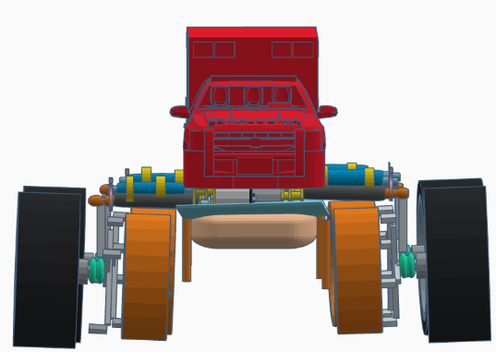

Fig.1.1 Runway Position of Air Ambulance

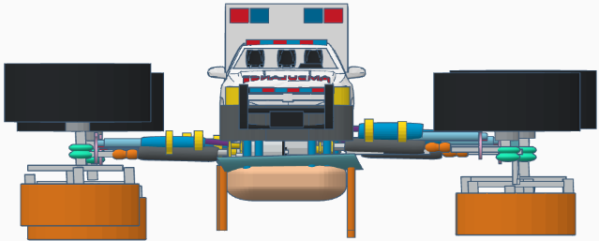

Fig.1.2 Flying Position of Air Ambulance

The Flying system of the air ambulance will be launched at the time of severe emergency. This will consumes less time to arrive the hospital or a clinic at a right time. The air ambulance will reach out the height of the 30-40 feet from the ground level. The air ambulance is travelling around the 150 km/hr in the sky. While we cannot able to fly above the ground level due to some obstacles or any other disturbances, we are going to use the water transportation (seaways) for driving to arrive the infirmary.

During this transportation, the structure of the ambulance is to be modified according to the buoyancy of the water. This mechanism will help the air ambulance to float on the water along the water flow. This water transportation is better than the air or road transportation due to free of traffic congestion and easy to travel to reach the destination.

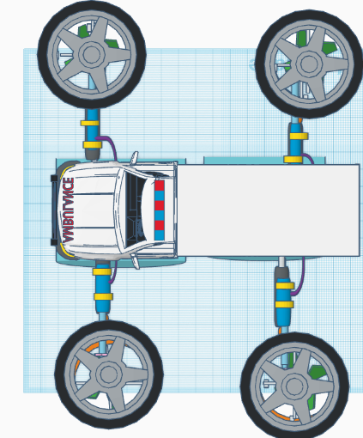

Fig.1.3 Water Floating Position of Air Ambulance

So the air transportation and water transportation of an Air Ambulance are to be very helpful in rescuing and save the patient lives. This will gives the relief to a patients and their relatives from the fear of traffic blockage.

In conclusion, the integration of drones and helium gas balloons in air ambulance services holds immense potential for transforming emergency medical services. By harnessing the capabilities of these technologies, we can overcome geographical barriers, optimize response times, and improve the overall effectiveness of emergency medical care. However, addressing regulatory

# CHAPTER – 2

**LITERATURE SURVEY**

**2.1 PAN, G., & ALOUINI, M.-S. (2021). FLYING CAR TRANSPORTATION SYSTEM: ADVANCES, TECHNIQUES, AND CHALLENGES.[1]**

Pan, G., et all contemplated on “FLYING CAR TRANSPORTATION SYSTEM: ADVANCES, TECHNIQUES, AND CHALLENGES,” The aim of this work is to develop a flying vehicle transportation due to expanding population in the world. All of the people are using the transportation. This makes a concern of traffic congestion. To come across this problem, the main motive is to utilize the unoccupied near-grounded spaces (NGS). Flying cars are not as similar as from the road transportation. There are no more competencies during flying in the air. Usually, the lack of flying car transportation in the current period. So the aim of the study is to describe modern advances, challenges and techniques of FCTS. Flying car will improve the recent transportation. At last, this will be helpful in commercializing and helpful in rescuing of the people. We list a few of FCTS' special attributes below: 1) Flying cars fitted with power cells that potentially produce zero direct discharges and emissions are encouraged as environmentally friendly transportation; 2) Utilizing the underutilized and abundant NGS resource will enable congestion-free mobility; 3) Flying cars, unlike ground-based transportation systems, can achieve shorter journey paths since they are not constrained by physical infrastructure, making flexible and quick door-to-door transit possible; 4) Less infrastructure on the ground is needed; the majority of FCTS operate in near-ground airspace, and the vertical take-off and landing (VTOL) mode has been accepted as the primary and widely used method for flying automobiles; 5) Less traffic congestion means more room is available for people on the ground.

**2.2 Md Mohaimenuzzaman, S. M. Monzurur Rahman,1 Musaed Alhussein, Ghulam Muhammad, and Khondaker Abdullah Al Mamun. (2016). ENHANCING SAFETY IN WATER TRANSPORT SYSTEM BASED ON INTERNET OF THINGS FOR DEVELOPING COUNTRIES [2]**

Throughout the year, accidents on inland waterways in developing nations frequently result in fatalities, injuries, financial losses, and a sizable number of individuals going missing. As a result, many families are losing loved ones, which causes great suffering. For the emerging countries, the aforementioned backdrop necessitates an intelligent, safe, and dependable water transportation infrastructure. Although the idea of an Intelligent Transport System (ITS) may be used to create such a system, ITS has flaws, and the Internet of Things (IoT) offers a fresh approach to its creation. In this research, a methodology for converting the water transportation system into an IoT-based intelligent system is proposed. The IEEE 802.15.4 network standard, 3G cellular technology, and IPv6-based machine-to-machine (M2M) protocol all significantly contribute to this suggested Internet of Things system

**2.3 Kaushik Rajashekara, Qingchun Wang, and Kouki Matsuse(2016). FLYING CARS: CHALLENGES AND PROPULSION STRATEGIES, [3]**

Throughout the history of automobiles and planes, developing and commercializing flying cars has always been a goal. This article gives an overview of the evolution of flying automobiles over the years. The difficulties with wide-scale adoption and the technological difficulties, particularly those pertaining to lift and propulsion, are discussed. There is growing interest in flying vehicles and increased electrification of these vehicles as a result of technological advancements in engines, electric motors, power converters, and communications. This article also looks at VTOL, propulsion systems for operation similar to that of a vehicle and an aeroplane, and the difficulties and needs of creating a hybrid or pure electric flying car.

**2.4 Brandon R. Sutherland(2019).FLYING CARS FOR GREEN TRANSPORTATION [4]**

Brandon R. Sutherland proposed the FLYING CARS FOR GREEN TRANSPORTATION. In this paper the author done the research on flying vehicle without affecting globalization by harmful exhausting gases and noises. Nowadays, so many transportation such as fleet of trucks, planes, trains, ships are taken place by fossil fuels in our earth. This sector alone contains over 28% of all Green house gas (GHG). Most of these vehicles are emitting the carbon-di-oxide(CO2). The main purpose of this paper is decarbonization of transportation which is accomplished by using hydrogen fuel cells, batteries and sustainable biofuels. This will saves 60% of fuel and reducing GHG emissions only by roadways conveyance by switching into an autonomous vehicle. To make a travel of aviation in every urban cities, we would require takeoff and landing aircraft (VTOLs). Every vehicle commuter's dream is to take off and soar to work in an aircraft on a direct course while oblivious to the underlying traffic jam during rush-hour gridlock.

**2.5 Mernout Burger, Bart De Schutter(2013).ENERGY-EFFICIENT TRANSPORTATION OVER FLOWING WATER [5]**

Water needs to be transported in order to buffer water to prevent floods downstream during rainy times, maintain river water levels to guarantee minimum depths for goods or preserve water for upcoming dry seasons. The speed of the water in rivers and canals is influenced by this manipulation of water flows, which in turn impacts the speed and energy utilisation of vessels used for transportation across water. The impact of varying water speeds (due to tide or river flows) might be considered while thinking about the challenge of scheduling micro-ferries in a harbour with the intention of providing energy-efficient schedules for passenger pickups and deliveries. This study describes how flowing water affects energy-efficient scheduling and suggests a approach using mixed-integer linear programming to address the issue.

**2.6 Bogdan Radu, Shelton, CT(2013), FLYING VEHICLE [6]**

A vehicle features a flying mode that allows it to fly like a VTOL/STOL aircraft or a helicopter, and a roadable configuration that is comparable to an automobile in which several rotors are stored inside the vehicle. This invention relates broadly to a vehicle that, with minimal configuration adjustments, can travel on land, on water, and in the air. Some known aircraft, such as the V22 Osprey air craft type, have tiltable rotors that enable vertical takeoff and landing. Within specified parameters, the propellers of helicopters can be inclined, which is vitally necessary for their control. Helicopters on the ground typically have very limited mobility, if any at all, while having a total of six degrees of freedom for moving along or turning around all three axes during flight configuration.

**2.7 Adekunle Mofolasayo(2019),POTENTIAL POLICY ISSUES WITH FLYING CAR TECHNOLOGY** **[7]**

A desired idea for reducing traffic congestion throughout the world is the flying-car concept. While there are many benefits to flying cars, such as lower construction and maintenance costs, a decreased reliance on road infrastructures, increased dependability of travel times, and reduced congestion, there are also drawbacks that could make this technology unwelcome if proper technological implementations and planning are not made to ensure the safety of people both on the ground and in the air. This research assesses the possible benefits and drawbacks of flying-car technology and suggests solutions to these issues. This paper examined, among other things, the necessity to provide suitable tracking systems for flying vehicles, the need to ensure effective law enforcement before flying-car technology is permitted on a broad scale. The need for technological innovations to reduce the effects of any mechanical failures or accidents on both the occupants of the flying-car and people on the ground, and the requirement for mandatory collision avoidance technology systems for flying cars. enforcement systems to control misuse of the technology. It is intended that this paper would increase curiosity about possible methods for harnessing this technology for the good of humanity.

**2.8** **Harsh A. Nakum(2020), AIR CAR: A REVIEW ON THE INVENTION OF FLYING AUTOMOBILE** **[8]**

The architecture of a flying automobile and the problem of traffic management in the modern world are the main topics of this essay. A feasible solution to this problem would be to create a flying or hovering automobile that can remove the burden off the congested roadways. Given recent innovations in the design, construction, and use of flying machines, flying automobiles are no longer only a possibility but rather a need for the near future. In terms of developing a conceptual design for a flying vehicle that can transport two people, building a model, and conducting ground and in-flight testing, the viability and feasibility of such an idea were investigated. A automobile that is considered to be a roadable aircraft that may be used for two reasons is called a "flying car."both moving through the air and on the ground. An improvement on an automobile, the flying car helps people in busy locations to get around problems. Flying cars will need to go by the same laws as modern cars do, and it is at this point that the development of virtual "highways in the sky" becomes apparent. These skyways would be a system of planned routes under the management and control of the flying vehicles' air activities. In order to maintain proper spacing between each flying car, the computer system will also maintain the flying cars' movement in terms of speed and course. The systems might consist of a configuration of computers that can control all of the region it protects from the flying automobiles.

**2.9 Nasir Saeed, Tareq Y. Al-Naffouri, and Mohamed-Slim Alouini(2021) WIRELESS COMMUNICATION FOR FLYING CARS [9]**

There are several problems with the current ground-based transit systems, chief among them the high cost of infrastructure expansion, the scarcity of available land, and the expanding metropolitan population. In order to create flying vehicles, also known as electric vertical takeoff and landing aircrafts (eVTOLs), the automotive and aviation sectors are working together. These eVTOLs will make transit in cities and suburbs dependable and quick. Wireless communication networks must be well-developed for eVTOLs to operate safely. To deliver services to flying automobiles, existing communication technologies must be improved. We provide a number of doable possible options for communication between eVTOLs and with the ground. These options include satellites, tethered balloons, high-altitude platforms, and on-ground three-dimensional cellular networks.

**2.10 Reni Varghese ,Ayushi Nair , Libin George Alexander, Sajilal R Nair,Mohamed Moniskhaleel (2015), COMPARISON OF FLYING CARS SINCE 2000 AND FACTORS CONSIDERED FOR ITS CONCEPTUAL DESIGN [10]**

A rudimentary understanding of the elements that must be taken into account for the conceptual design of flying automobiles is attempted in this essay. Additionally, the key specifications of flying cars developed since 2000 are compared, and an assessment is made of which flying vehicles most closely meet these major criteria and other requirements for successful flying cars. It is not very simple to create a successful flying automobile, as this paper has shown. In comparison to building the vehicle only as a car or an aeroplane, it must take into account a lot more other issues, such as safety and extremely short takeoff and landing distances. The three most popular flying vehicles at the moment are the PAL-V, Transition, and Aeromobile 3, They are anticipated to be commercially accessible soon as they meet practically all criteria for successful flying automobiles. The TF-X and XplorairPX200 are two examples of future flying automobiles that will be superior to those we have now.

# CHAPTER – 3

**EXISTING AND PROSED SYSTEM**

**3.1 EXISTING SYSTEM**

A medically prepared vehicle that delivers patients to treatment centres like hospitals is called an ambulance. Typically, the patient receives out-of-hospital care while being transported. Emergency medical services (EMS) use ambulances to respond to medical emergencies.

When any medical needs happened, ambulances are the first preference to treat the patients. Although this system seems to be efficient, at times there are some drawbacks because there is a lot of traffic jam occurred in the urban areas due to the increase of population. This will delay the ambulances to reach the infirmary on time. So that many people’s lives have become questionable.

Even if they carry patients, they fear that they will not go to the hospital because they will get stuck in the traffic jams. This frustration is also become a cause of death of patients. To overcome these disadvantages we propose a model,

* Firstly, this system would be more beneficial, if it was travelling with free of traffic to arrive at the hospital.
* Nowadays due to recently happened cases such as congestion in the roadways by lack of infrastructure planning for city roadways is the cause of traffic jams. Roadways are restricted by the construction of properties, workplaces flyovers, and metros; as a result, traffic gets diverted into alternative paths, resulting in chaos.
* Drone systems are currently used for aerial Photography, agriculture, search and rescue, shipping and delivery etc., and can modify some hardware components and adding some new components as we want.
* This innovation also have a water transportation mechanism, if the places are doesn’t suit for aviation.

**3.2 EXISTING BLOCK DIAGRAM**

AMBULANCE

Boat ambulance

(TEAM 3)

Basic Air Ambulance

(TEAM 1)

Road Ambulance

(TEAM 2)

Patient

Patient

Patient

Rescue

Rescue

Hospital

Rescue

Fig.3.1.Existing system

In this existing system, there are three types of rescue teams. But they are not combined and are alone. However, each of them consists of separate drawbacks like for an basic air ambulance, if there is a storm, it will be difficult to drive the ambulance on air, for road ambulance traffic congestion is the major concerns and flooding is the main worry for boat ambulance. In that crucial moment, for most of the patients, it is difficult to get into the hospital. Even if they do, it is very risky to save the patient before anything happens. It is also very unreliable.

**3.3 DISADVANTAGES**

* Delay occurs
* Even lives may not be saved
* Highly pressurized.

**3.4 PROPOSED SYSTEM**

The challenging situation facing by each patients now-a-days gave hope to bring their lives safer. The road should not be congested for an ambulance. So the proposed system is to get over the above disadvantages, we are introducing a new model of air ambulance. The working of selected design is as follows:

* When this ambulance goes on the road, it runs on the road like a normal vehicle, and when the road is jammed, the rod installed in this vehicle in all four directions will lift the vehicle.
* When it is lifted, the direction of the four wheels will change. Helium gas installed on all sides of the vehicle reduces the weight of the vehicle when reduced in such a way that the vehicle can easily fly up to a certain distance.
* When the front wheel of the vehicle rises up to 20 degrees and the rear wheel rises up to 30 degrees, it reaches the destination easily with the help of a boat mounted on the wheel of the vehicle. A magazine can easily save lives.

A

B

30º 20º

1. (b)

Fig 3.2(a) angle of front wheel rise up

3.2(b) angle of rear wheel rise up

* The places where flight is not possible, the vehicle will also go on water. A helium gas balloon attached to the bottom of the vehicle makes the vehicle buoyant when the vehicle is submerged for a certain distance.
* There are three different methods are available in ambulances. In our proposal, we all have a combined of three-in-one manner.

**3.5 PROPOSED BLOCK DIAGRAM**

**3.5.1 Proposed system of Air Ambulance**

AIR

AMBULANCE

Boat ambulance

Basic Air Ambulance

Road Ambulance

TEAM 1

Patient

Rescue

Hospital

Fig.3.3.Proposed System of Air Ambulance

**3.5.2. Block Diagram of Air Ambulance**

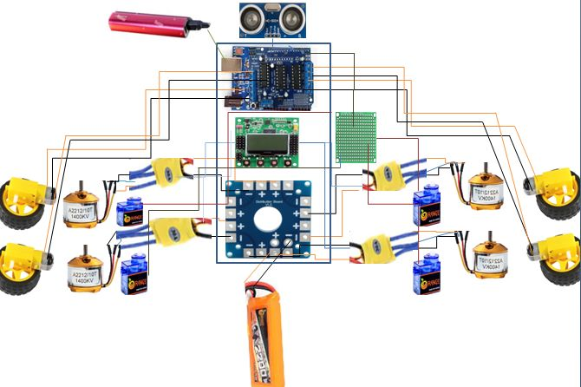

Fig.3.4.Proposed Block Diagram of Air Ambulance

**3.6 PROPOSED BLOCK DESCRIPTIONS**

**3.6.1 Motor:**

Multiple motors are used like brushless motor, servo motor and gear motor. An electric motor that runs on direct current (DC) and they are needed to move a vehicle from one place to another place. Although the upfront costs are higher, they provide clear advantages over any other motors and is ultimately more affordable.

**3.6.2 Controllers**

The controllers such as Flight Controller, Arduino UNO, Electronic speed controllers (ESCs) are tools that drone controllers can use to regulate and manage the motor speed of the aircraft. They have less complex features than other microcontrollers and they are also easily available and cheap in comparison of other microcontroller.

**3.6.3 Sensors**

An ultrasonic sensor is a device that uses ultrasonic waves to calculate a distance to an item. An ultrasonic sensor transmits and receives ultrasonic pulses using a transducer to determine the proximity of an item. No matter the shape, color, or surface roughness of the object, ultrasonic sensors can measure the distance to it. They can also gauge how close or far away an object is.

**3.7 ADVANTAGES**

* Major advantage of the proposed system is that it is adaptable.
* The proposed system consists of all the three ways to reach the hospital.
* It carries the patient safer and faster than any other ambulances**.**

# CHAPTER – 4

# SYSTEM REQUIREMENTS

# 4.1 HARDWARE REQUIREMENTS

* Brushless Motor (A2212)
* Electronic Speed Controllers (ESCs) 30A
* Flight Controller kk 2.25
* Lithium Poly Battery (2200mAh)
* Propellers (5 inch)
* Servo Motor
* Arduino UNO
* Gear Motor
* Air Bag
* Helium Gas
* LCD
* Transmitter & Receiver
* Aluminium Channel
* Ultrasonic Sensor
* Arduino Shelt (Motor Controller)

**4.2 SOFTWARE REQUIREMENTS**

* Arduino IDE
* Embedded C Program( inbuilt FC)
  1. **HARDWARE SPECIFICATION**
     1. **Brushless Motor**

A motor transforms the electrical energy that is supplied into mechanical energy. Different motor types are frequently used. Among them, brushless DC motors (BLDC) are popular in many applications and have great efficiency and outstanding controllability. Compared to other motor types, the BLDC motor provides advantages for power conservation.

A brushless motor system is often built similarly to a permanent magnet synchronous motor (PMSM), although it can also be an induction (asynchronous) motor or a switching reluctance motor. The rotor and stator may be axial (flat and parallel), outrunners (the stator is encompassed by the rotor), or inrunners (the rotor is surrounded by the stator). They may also use neodymium magnets.

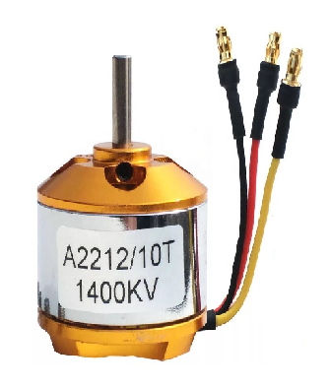

Fig.4.1. Brushless motor

High power-to-weight ratio, high speed, almost immediate control of speed (rpm) and torque, high efficiency, and cheap maintenance are all benefits of brushless motors over brushed motors. Brushless motors are used in a variety of devices, including hand-held power tools, model aeroplanes, automobiles, and computer peripherals (disc drives, printers).

* + 1. **Electronic Speed Controllers (ESCs)**

An electrical circuit known as an electronic speed control (ESC) controls and regulates an electric motor's speed. It consists of 30 amps and it might also offer dynamic braking and motor reversing. In radio-controlled models that are powered by electricity, tiny electronic speed controls are employed.

Brushed DC motors and brushless DC motors need various types of speed regulation. By adjusting the voltage on its armature, a brushed motor's speed can be3 managed.

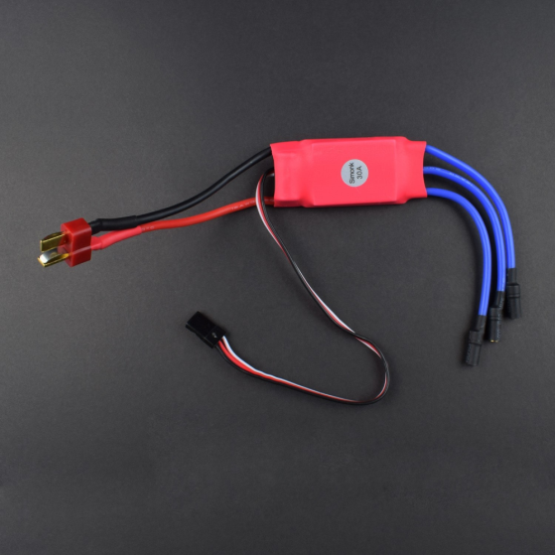

Fig.4.2. Electronic speed controller

A brushless motor demands a unique operating strategy. By altering the timing of current pulses given to the motor's various windings, the speed of the motor can be changed.

* + 1. **Flight Controller**

A group of sensors are attached to the flight controller. The flight controller receives data from these sensors about the aircraft, including its height, orientation, and speed. Common sensors include a barometer for height, an inertial measurement unit (IMU) for angular speed and acceleration, and distance sensors for obstacle detection. The drone filters a lot of this information and merges some of it, much like how people perceive things. This results in information that is more accurate and efficient. Advanced flight controls are able to perceive more precisely and quickly identify differences.

. 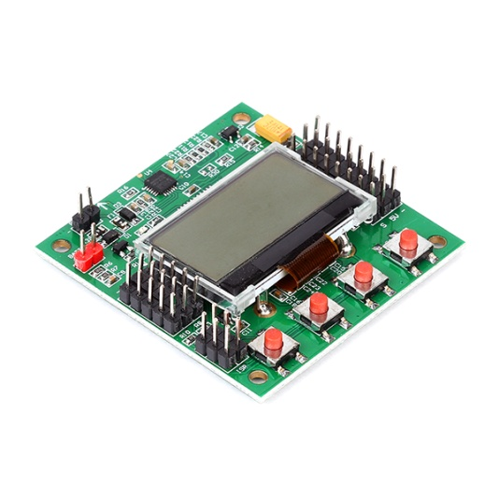

Fig.4.3. Flight Controller

* + 1. **Lithium Poly Battery**

Alithium polymer battery, or more accurately, a lithium-ion polymer battery, is a rechargeable battery of lithium-ion technology that uses a polymer electrolyte rather than a liquid electrolyte. This electrolyte is made up of high-conductivity semisolid (gel) polymers. These batteries are employed in applications where is important, such as mobile services, radio-controlled aircraft and some electric vehicles. They offer better specific energy than other lithium battery types.

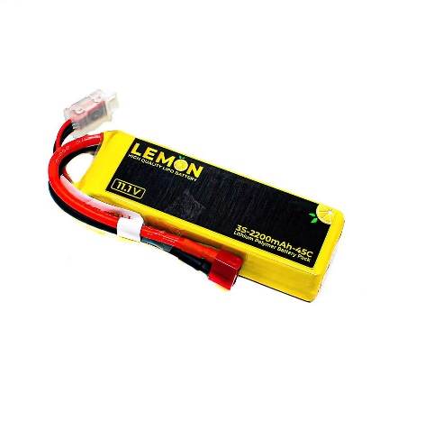

Fig.4.4. Lithium battery(Lemon)

* + 1. **Propeller**

A propeller is a mechanical device that has a hub that rotates and distributing blades pitched to form a spiralling helical structure that, when rotated, applies linear thrust to a working fluid like air or water. To provide a push to move a boat through water or an aeroplane through the air, or to pump fluid through a pipe or duct, propellers are utilized. The blades are designed to leverage Bernoulli's principle, which applies force to the fluid, to create a pressure difference between their two surfaces as they rotate through the fluid.

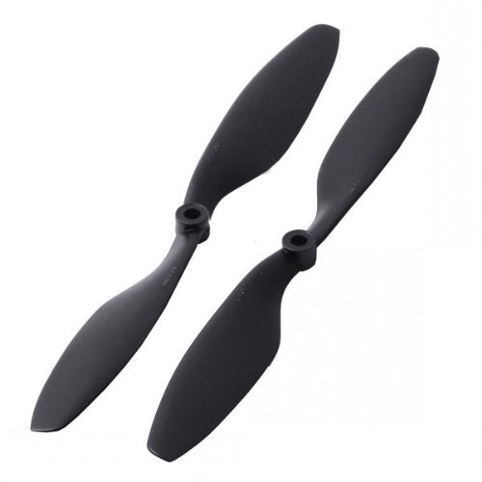

Fig.4.5. Propeller

* + 1. **Servo Motor**

The rotary actuator or linear actuator known as a servomotor (or servo motor) enables accurate control of angular or linear position, velocity, and acceleration. It consists of an adequate motor connected to a position feedback sensor. It also requires a rather sophisticated controller, generally a special module created just for use with servomotors. Although the word "servomotor" is frequently used to describe a motor appropriate for use in a closed-loop control system, servomotors are not a particular kind of motor. Applications for servomotors include robotics, CNC equipment, and automated manufacturing.

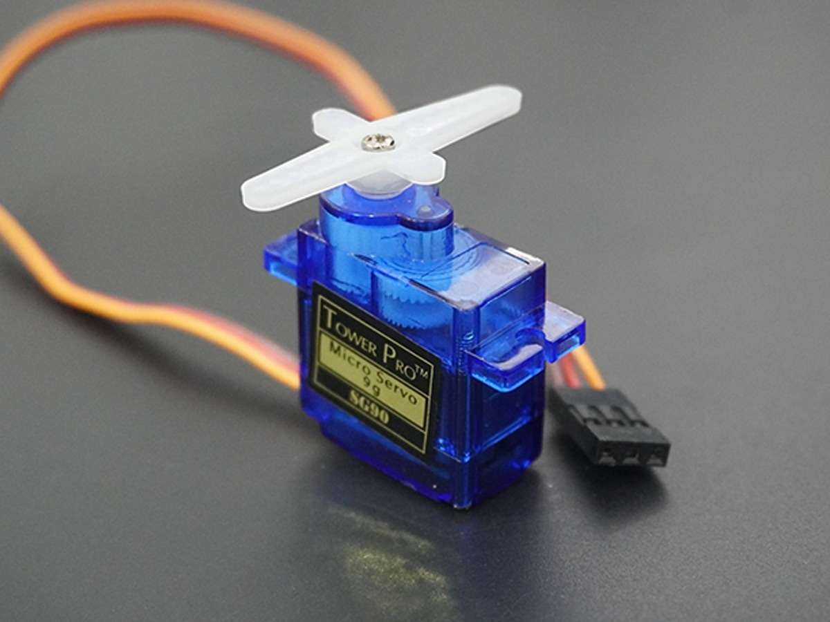

Fig.4.6. Servo Motor

The motor can rotate around 90º clockwise and reverse direction. Continuous rotation servos write(0) function will make the servomotor spin counter-clockwise at full speed. The Servo1. write(90) function will stop the motor and Servo1. write(180) will turn the motor clockwise at full speed.

**4.3.7 Gear Motor**

A mechanical device called a gear motor consists of an electric motor and a gearbox with numerous gears within. In order to complete a task at a specific speed, the motor's gearbox must reduce its speed and raise its torque. Gear motors are more usable and highly adaptable in any area of mechanical automation thanks to the addition of the gearbox on the motor and the extremely simple design that can be easily customised to the needs of the customer (industrial and home automation, printers, vending machines, to name a few applications). The motor might be stepper, brushless, or with brushes.

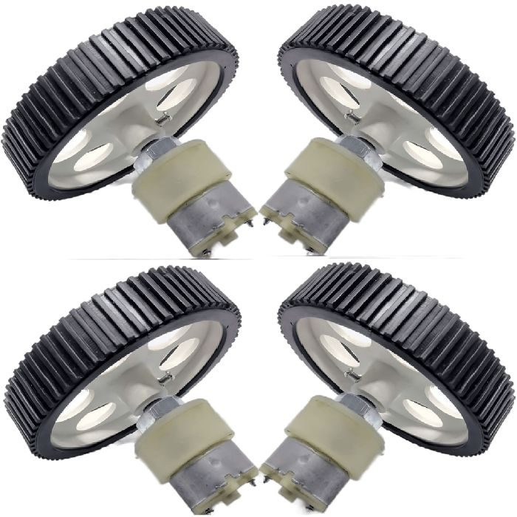

Fig.4.7. Gear Motor

This gear motor is used for turning of wheels in the given direction. The Most Common Applications of Geared Motors DC gear motors are most commonly used in vehicle industries such as truck power cranes, windscreen wiper motors, plus power seats or power window motors.

* + 1. **Air Bag**

An Air bag is a lifting bag is a piece of diving gear made out of a sturdy, airtight bag with straps that is used to move heavy objects over water thanks to the buoyancy of the bag. The diver can either send the bulky object alone to the surface or shift it horizontally underwater. The capacity of the lift bag should be appropriate for the work at hand. A runaway or other out-of-control ascent could happen if the lift bag is grossly large. To manage buoyancy during ascent, dump valves may be included in lifting bags that are available for purchase, however this is a risky procedure with a significant chance of becoming entangled in an uncontrolled lift or sinking.

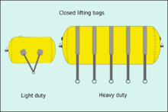

Fig.4.8. Air bag

There are lifting bags that are used in machines as a form of pneumatic actuator that gives load over a wide region, as well as lifting bags that are used on land as short lift jacks for lifting automobiles or big goods. For instance, rollercoaster brake mechanisms use these lifting bags of the AS/CR type.

**4.3.9 Helium Gas**

Helium is most commonly used to fill balloons for celebrations and parades since it is a secure, non-flammable gas. Helium, however, is an essential element in a variety of industries, including high-tech manufacturing, medical technology, space exploration, and national defence. Helium gas is a non-toxic that is obtained from natural gas. Helium Gas was first detected in sun.

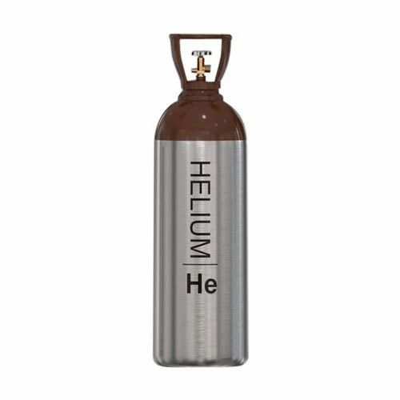

Fig.4.9. Helium Gas Cylinder

The properties of the helium gas such as chemical formula He and Electronic configuration is 1S2. Hydrogen is lighter than air and as oxygen is present in the air. Helium is lighter than air and it is a non-combustible gas so it used to fill balloons.

**4.3.10 LCD**

LCD (Liquid Crystal Display) screen is an electronic display module and find a wide range of applications. A 16x2 LCD display is very basic module and is very commonly used in various devices and circuits.

A 16x2 LCD means it can display 16 characters per line and there are 2 such lines. In this LCD each character is displayed in 5x7 pixel matrix. This LCD has two registers, namely, Command and data.

The data is the ASCII value of the character to be displayed on the LCD. Liquid Crystal Displays are used for display of numeric and alphanumeric character in dot matrix and segmental displays. The two liquid crystal materials which are commonly used in display technology are nematic and cholesteric whose schematic arrangement of molecules is shown in fig. In this all the molecules align themselves approximately parallel to a unique axis (director), while retaining the complete translational freedom. The liquid is normally transparent, but if subjected to a strong electric field, disruption of the well ordered crystal structure takes place causing the liquid to polarize and turn opaque. The removal of the applied electric field allows the crystal structure to regain its original form and the material become transparent.

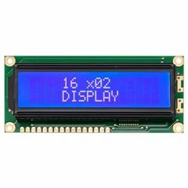

Fig.4.10. Liquid Crystal Display

**Features of LCD**

* Operating voltage range is 3-20V ac.
* It has a slow decay time. Response time is 50 to 200 ms.
* Viewing angle is 100 degree.
* Invisible in darkness. Requires external illumination.
* Life time is limited to 50,000 hours due to chemical graduation.

**Advantages of LCD**

* The voltage required is small.
* They have low power consumption. A seven segment display requires about 140W (20 W per segment).

**4.3.11 Transmitter & Receiver**

The transmitter you hold in your hands and the receiver you place inside your drone make up a radio control system. To drastically simplify things, your drone transmitter will read your stick inputs and relay them in almost real-time to your receiver. When the receiver receives this data, it sends it to your drone's flight controller, which causes the drone to move in accordance with that information.

The range limit, which commonly falls in the 1 kilometre range under normal circumstances, is the point at which the receiver can no longer properly hear what the transmitter is telling it. Think of trying to communicate with someone across a field. Your radio link's range will be influenced by a few variables, including:

* The output power of your transmitter: To comply with global standards, many operate just below the legal maximum.
* The receiver's sensitivity - The signal will go further with a more sensitive receiver, but under some circumstances it may also pick up more noise, similar to having superior hearing.
* The quality of your antennas at both ends - Antennas could be an entire article on their own but basically a larger antenna will send and receive a better signal. Often optimising your antenna placement will make a huge difference to the performance to the system.

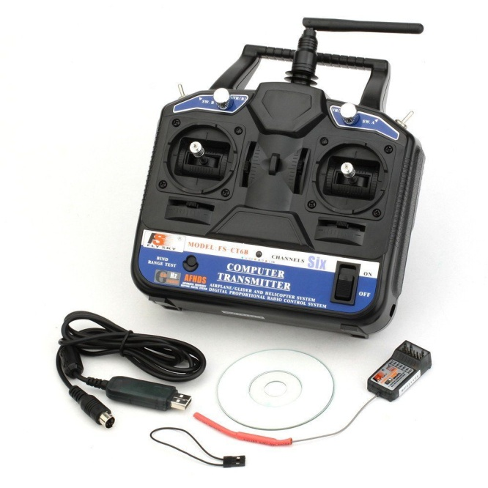

Fig.4.11. Transmitter and receiver

**4.3.12 Aluminium Channel**

An aluminium channel is a metal extrusion with a U-shape that looks like the letter "U." It frequently serves a variety of functions, including framing, support, reinforcement, and aesthetic ones, in building, manufacturing, and other industries. Here, it is using the aluminium channel as a frame for drone

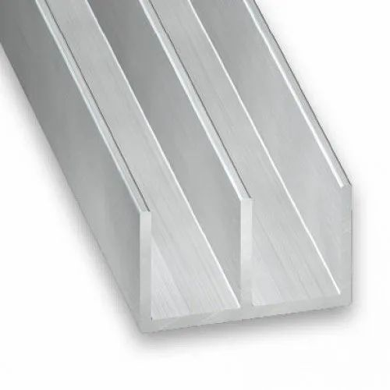

Fig.4.12. Aluminium Channel

Aluminium channels provide durable and lasting protection and can support a large amount of weight, including cabinets, wardrobes and other storage and building items.

**4.3.13 Ultrasonic Sensor**

An ultrasonic sensor is a device that uses ultrasonic sound waves to calculate a distance to an item. An ultrasonic sensor transmits and receives ultrasonic pulses from a transducer to determine the proximity of an item. Ultrasonic sensors are used as proximity sensors. They can be found in parking technology and anti-collision safety systems. They are also used in robotic obstacle detection systems and manufacturing engineering. Compared to infrared (IR) sensors in proximity sensing applications, ultrasonic sensors are less susceptible to interface from smoke, gases, and other airborne particles.

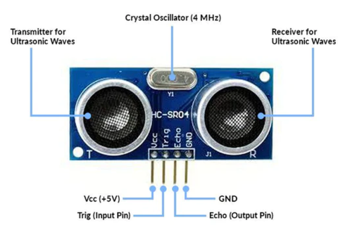

Fig.4.13. Ultrasonic Sensor

Ultrasonic sensors are also used as level sensors to detect, monitor, and control liquid levels in closed vessels (such as chemical plant drums). Most notably ultrasound technology has enabled the medical industry to image internal organs, identify tumours, and ensure the health of babies in the womb. With microcontroller platforms like the Raspberry Pi, ARM, PIC, Arduino, Beagle Board, and many more, our ultrasonic proximity level and distance sensors are often employed. Ultrasonic sensors will send sound waves in the direction of the target and calculate its distance by timing how long it takes for the waves to bounce back to the sensors. In addition, to collision avoidance systems also employ ultrasonic sensors.

Here, implemented ultrasonic sensor with Arduino. Before interfacing let us see the pinout of the ultrasonic sensor

**FOUR PINS IN THE ULTRASONIC SENSOR**

|  |  |
| --- | --- |
| Vcc | Power supply +5V |
| Gnd | Common ground |
| Trigger pin | To start the sensor |
| Eco pin | Receive the signal |

Table 4.1

**4.3.14 Working Principle of Ultrasonic Sensor**

The principle of Ultrasonic Sensor is either similar to sonar or radar which evaluates the target/object attributes by understanding the received echoes from sound/radio waves correspondingly. These sensors produce high-frequency sound waves and analyze the echo which is received from the sensor. The sensors measure the time interval between transmitted and received echoes so that the distance to the target is known.

The transmitter and receiver are the two main parts of an ultrasonic sensor. These areas are close together to ensure that the sound travels directly from the transmitter to the intended target and back to the receiver. Calculation mistakes are minimized when there is little space between the transmitter and receiver sections.

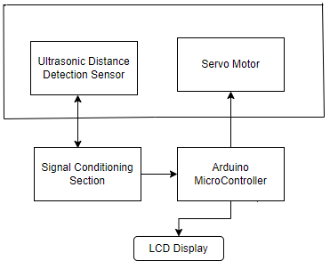

Fig.4.14. Ultrasonic Sensor Block Diagram

**4.3.15 Features of Ultrasonic Sensor**

Knowing the specifications of an ultrasonic sensor helps in understanding the reliable approximations of distance measurements.

* The sensing range lies between 40 cm to 300 cm.
* The response time is between 50 milliseconds to 200 milliseconds.
* The Beam angle is around 50.
* It operates within the voltage range of 20 VDC to 30 VDC
* Preciseness is ±5%
* The frequency of the ultrasound wave is 120 kHz
* Resolution is 1mm
* The voltage of sensor output is between 0 VDC – 10 VDC
* The ultrasonic sensor weight nearly 150 grams
* Ambient temperature is -250C to +700C
* The target dimensions to measure maximum distance is 5 cm × 5 cm

**Advantages**

* These devices are not impacted by the target’s colour.
* The device shows flexibility in its distance measurement range where it holds the capability of measuring in the range of a few centimetres to five meters.
* It provides consistent outcomes and shows high reliability.
* High precision device.
* The measurements can be made every second thus showing rapid refresh rates.
  1. **SOFTWARE SPECIFICATION**
     1. **Arduino ide**

Arduino is an open-source electronics platform based on easy-to-use hardware and software. Arduino boards are able to read inputs- light on a sensor, a finger on a button, or a Twitter message – and turn it into an output – activating a motor, turning on an LED, publishing something online. You can tell your board what to do by sending a set of instructions to the microcontroller on the board. To do so you use the Arduino programming language (based on Wiring), and the Arduino Software (IDE), based on processing.

Over the years Arduino has been the brain of thousands of projects, from everyday objects to complex scientific instruments. A worldwide community of makers- students, hobbyists, artists, programmers, and professional – has gathered around this open-source platform, their contributions have added up to an incredible amount of accessible knowledge that can be of great help to novices and experts alike. All Arduino boards are completely open-source, empowering users to build them independently and eventually adapt them to their particular needs, The software too, is open-source and it is growing through the contributions of users worldwide.

* + 1. **Features**

**Inexpensive –** Arduino boards are relatively inexpensive compared to other microcontroller platforms. The least expensive version of the Arduino module can be assembled by hand, and even the pre-assembled Arduino modules cost less than $50.

**Cross-platform –** The Arduino Software (IDE) runs on Windows, Macintosh OSX, and Linux operating systems. Most microcontroller systems are limited to Windows.

**Simple, clear programming environment –** The Arduino Software (IDE) is easy-to-use for beginners, yet flexible enough for advanced users take advantages of as well. For teachers, it’s conveniently based on the Processing programming environment, so students learning to program in that environment will be familiar with how the Arduino IDE works.

**Open source and extensible software –** The Arduino software is published as open source tools, available for extension by experienced programmers. The language can be expanded through C++ libraries, and people wanting to understand the technical details can make the leap from Arduino to the AVR C programming language on which it’s based. Similarly, you can add AVR-C code directly into your Arduino programs if you want to.

**Open source and extensible hardware –** The plans of the Arduino boards are published under a Creative Common license, so experienced circuit designers can make their own version of the module, extending it and improving it. Even relatively inexperienced users can build the breadboard version of the module in order to understand how it works and save money.

* + 1. **Arduino software (ide)**

Sketches are computer programmes created using the Arduino Software (IDE). These drawings are created in a text editor and saved as files with the.ino extension. The editor offers functions for text replacement and text searching. When saving and exporting, the message section provides feedback and shows errors. The console shows text generated by the Arduino Software (IDE), including error messages in their entirety and other data. The configured board and serial port are visible in the window's bottom right corner. You may create, open, and save sketches, validate and submit programmes, view the serial monitor, and more using the toolbar buttons.

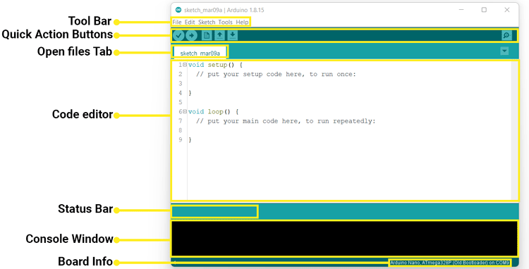

Fig.4.15. Arduino IDE

* + 1. **Third-party hardware**

Suppose for third-party hardware can be added to the hardware directory of your sketchbook directory. Platforms installed there may include board definitions (which appear in the board menu), core libraries, bootloaders, and programmer definitions. To install, create the hardware directory, then unzip the third-party platforms into its own sub-directory. (Don’t use “arduino” as the sub-directory name or you’ll override the built-in Arduino platform.) To uninstall, simply delete its directory.

**PREFERENCES**

Some preferences can be set in the preferences dialog (found under the Arduino menu on the Mac, File on Windows and Linux). The rest can be found in the preferences file, whose location is shown in the preferences dialog.

* + 1. **Boards**

The board selection has two effects: it sets the parameters (e.g. CPU speed and baud rate) used when compiling and uploading sketches; and sets and the file and fuse settings used by the burn bootloader command. Some of the board definitions differ only in the latter, so even if you’ve been uploading successfully with a particular selection you’ll want to check it before burning the bootloader.

Arduino Software (IDE) includes the built in support for the boards in the following list, all based on the AVR Core. The Boards Manager included in the standard installation allows to add support for the growing number of the new boards based on different cores like Arduino Due, Arduino Zero, Edison, Galileo and so on.

**STARTED WITH THE ARDUINO UNO**

The Arduino Nano is a small, complete, and breadboard-friendly board. It offers the same connectivity and specs of the UNO board in a smaller form factor.

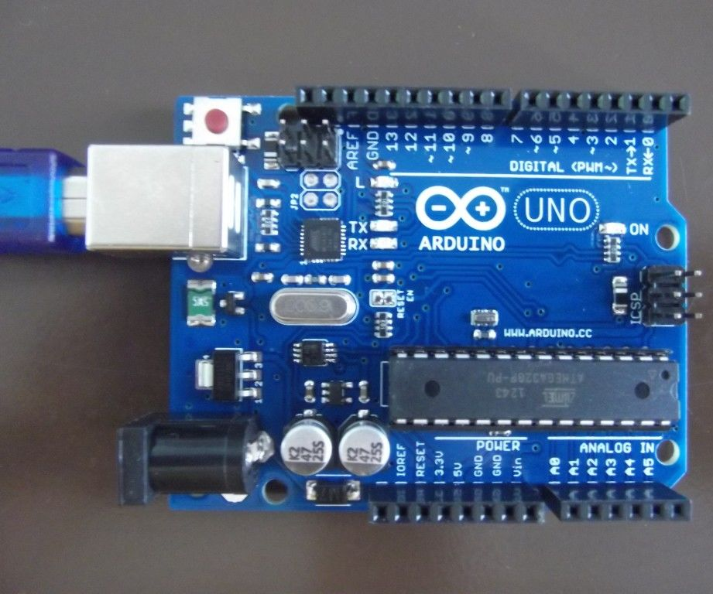

Fig.4.16. Arduino UNO Interface

The Arduino UNO is programmed using the Arduino Software (IDE), our Integrated Development Environment common to all the boards and running both online and offline. For more information on how to get started with the Arduino Software visit the Getting Started page.

**Arduino UNO on the Arduino Desktop IDE**

If you want to program your Arduino UNO while offline you need to install the Arduino Desktop IDE. To connect the Arduino UNO to your computer, you’ll need a Mini-B USB cable. This also provides power to the board, as indicated by the red LED.

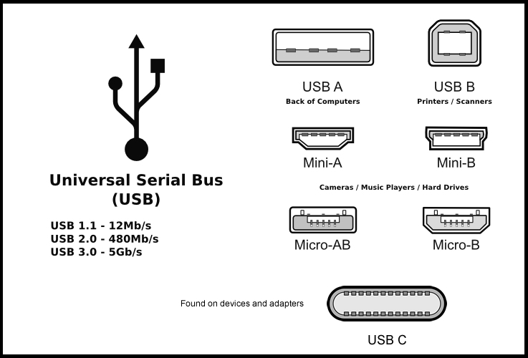

Fig.4.17. UNO Interfacing USB Types of Port

**OPEN YOUR FIRST SKETCH**

* Open the LED blynk example sketch: File > Examples > 0.1. Basics > air ambulance.

**Select your board type and port**

* Select Tools > Board > Arduino AVR Boards > Arduino UNO.

NOTE: We have updated the UNO board with a fresh bootloader. While boards manufactured before that date have this old bootloader. First check that **Tools** > **Board** > **Boards Manager shows you have the Arduino AVR Boards** 1.16.21 or later installed.

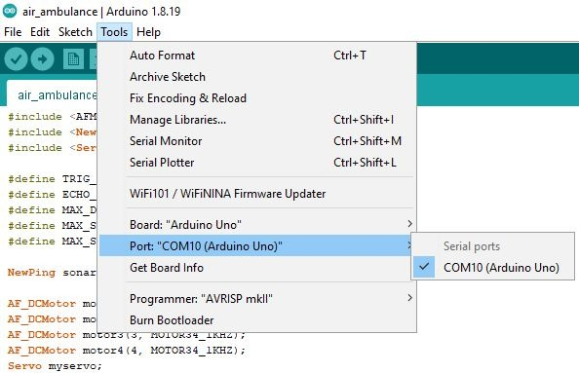

Fig.4.18. Select the UNO Port Type

Select the serial device of the board from the Tools | Serial Port menu. This is likely to be COM3 or higher. To find out, you can disconnect should be the Arduino board. Reconnect the board and select that serial port.

**Upload and Run your Sketch**

To upload the sketch to the Arduino UNO, click the Upload button in the upper left to load and run the sketch on your board:

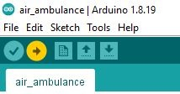

Fig.4.19. Upload to UNO

Wait a few seconds – you should see the RX and TX LEDs on the board flashing. If the upload is successful, the message “Done uploading.” Will appear in the status bar.

# CHAPTER – 5

# RESULT AND DISCUSSION

# The rescue begins when the patient in a worst situation to reach the hospital. It includes all the features of normal ambulance. If the medical team receive an emergency call from the patient side, they will alert the rescue team to reach out the patient immediately. Once the patient is picked up, they will give hope to the patient by the latest mechanism of our ambulance. The drone mechanism will be operated when the ambulance get stuck within the traffic which consists of four propellers along the side of a wheel to fly over the other vehicles, Sensors like ultrasonic sensor which is used to calculate the distance between vehicles where they allow to fly. To stable the ambulance while the propellers come out, it contains four stands at the time of shifting of wheels in a particular angle to make an ambulance to drift over the ground surface. Suppose we get stuck in the tunnels or distributed wire lines are passing over the head, the aviation will not be possible at that time. So we are using the Floating mechanism to drive on the water by using such airbags. By that the patient will arrive the hospital immediately and safely and save the patient lives from an endanger.

|  |  |
| --- | --- |
| Weight of the vehicle | Up to 4000 Kilograms (or) 4 tonnes |
| Motor Capacity | Around 18000 rpm |
| Hover | Up to 30 to 40 feet height |
| Speed | Approx 40 km/hr |

# Table 4.2

# 5.1 SIMULATION RESULT

# 

Fig.5.1.The image capturing code using Arduino IDE

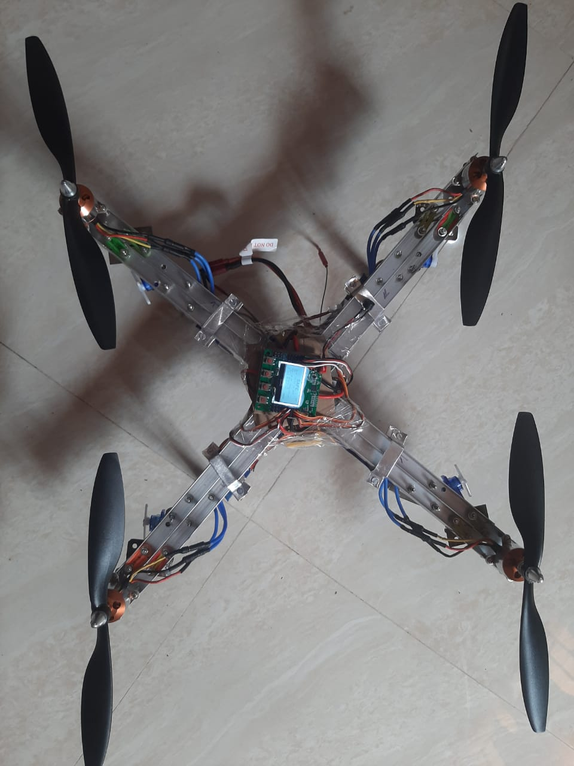

Fig.5.2.The Hardware Kit

The above picture represents the hardware kit of the drone setup of air ambulance.

# CHAPTER – 6

# CONCLUSION AND FUTURE WORK

# 6.1 CONCLUSION

# Our proposed system has arduino device for switching the wheel and operating the ultrasonic sensor. This system is used to control the servo motors to rotate the wheels in accordance of flying position and ultrasonic sensor is used to detect the nearby objects. It helps the patient to reach the hospital by airways and waterways. The major concern is the traffic congestion in the roadways. To overcome these situations, we are moving to the aviation and waterways mode. It will be faster than the roadways due to the free of congestion. Our motive is to save the lives of the people in the severe situations.

# 6.2 FUTURE WORK

# In future the fuel vehicles will become an electrical vehicles So they are using Android based IoT device is successful in providing safety to patients when they need an immediate treatment in a severe condition in manner of implementing in three ways to travel. By using sensors, boards and vehicle mechanisms they can control the whole system of the air ambulance. The medical team can also surveillance the status of the air ambulance.

# REFERENCES

# [1] PAN, G., & ALOUINI, M.-S. (2021). FLYING CAR TRANSPORTATION SYSTEM: ADVANCES, TECHNIQUES, AND CHALLENGES. IEEE ACCESS, 9, 24586– 24603

# [2] Md Mohaimenuzzaman,1 S. M. Monzurur Rahman,1 Musaed Alhussein,2 Ghulam Muhammad,2 and Khondaker Abdullah Al Mamun1. (2016). ENHANCING SAFETY IN WATER TRANSPORT SYSTEM BASED ON INTERNET OF THINGS FOR DEVELOPING COUNTRIES.2834616

# [3] Kaushik Rajashekara, Qingchun Wang, and Kouki Matsuse(2016). FLYING CARS: CHALLENGES AND PROPULSION STRATEGIES, 2325-5987/16©2016IEEE

# [4] Brandon R. Sutherland(2019).FLYING CARS FOR GREEN TRANSPORTATION, Joule 3, 1180–1189, May 15, 2019 ª 2019

# [5] Mernout Burger, Bart De Schutter(2013).ENERGY-EFFICIENT TRANSPORTATION OVER FLOWING WATER, 978-1-4673-5200-0/13/$31.00 ©2013 IEEE

# [6] Bogdan Radu, Shelton, CT(2013), FLYING VEHICLE, US 8,827,200 B2

# [7] Adekunle Mofolasayo(2019),POTENTIAL POLICY ISSUES WITH FLYING CAR TECHNOLOGY, 2352-1465 © 2020, 10.1016/j.trpro.2020.08.002

# [8] Harsh A. Nakum(2020), AIR CAR: A REVIEW ON THE INVENTION OF FLYING AUTOMOBILE, ISSN: 2278-0181

# [9] Nasir Saeed, Tareq Y. Al-Naffouri, and Mohamed-Slim Alouini(2021)

# WIRELESS COMMUNICATION FOR FLYING CARS, DOI: https://doi.org/10.21203/rs.3.rs-155561/v1

# [10] Miss Reni Varghese , Miss. Ayushi Nair , Mr. Libin George Alexander Mr. Sajilal R Nair, Mr. Mohamed Moniskhaleel (2015), COMPARISON OF FLYING CARS SINCE 2000 AND FACTORS CONSIDERED FOR ITS CONCEPTUAL DESIGN, ISSN: 2278-0181 Published by, www.ijert.org NCERAME - 2015 Conference Proceedings